Name: Atul Kumar Roll No. B55 Registration No: 12102801
Subject: Styling & Scripting for Web Development Assignment: 01
Answer:
<!DOCTYPE html>
<html lang="en">
<head>
<title>Multimedia</title>
</head>
<body>
<h1><center>Mutimedia Container<center></h1>
<table border="1" height="15" width="100%">
<tr>
<th>Image(Link to LPU website)</th>
<th><center>Video</center></th>
<th><center>Audio</center></th>

</tr>
<th>
<a href="https://www.lpu.in/"><img src="lpu logo.png"></a>
</th>
<th><video controls width=200px heigh=100px src="VID_20210626_183641.mp4"></th>
<th><audio controls width=200px heigh=100px src="_Dil_Mein_Ho_Tum_WHY_CHEAT_INDIA__Emraan_H,_Shreya_DRochak_K,_Armaan_M,_Bappi_L,_Manoj_M.mp3"></audio></th>
<tr>
<th colspan="3">
<center>
<iframe width=100%px height=250px src="https://www.wikipedia.org/"></iframe>
</center></th>
</tr>
<tr>
</tr>
</body>
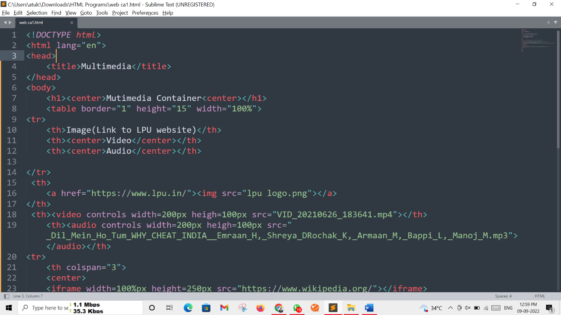
</html>

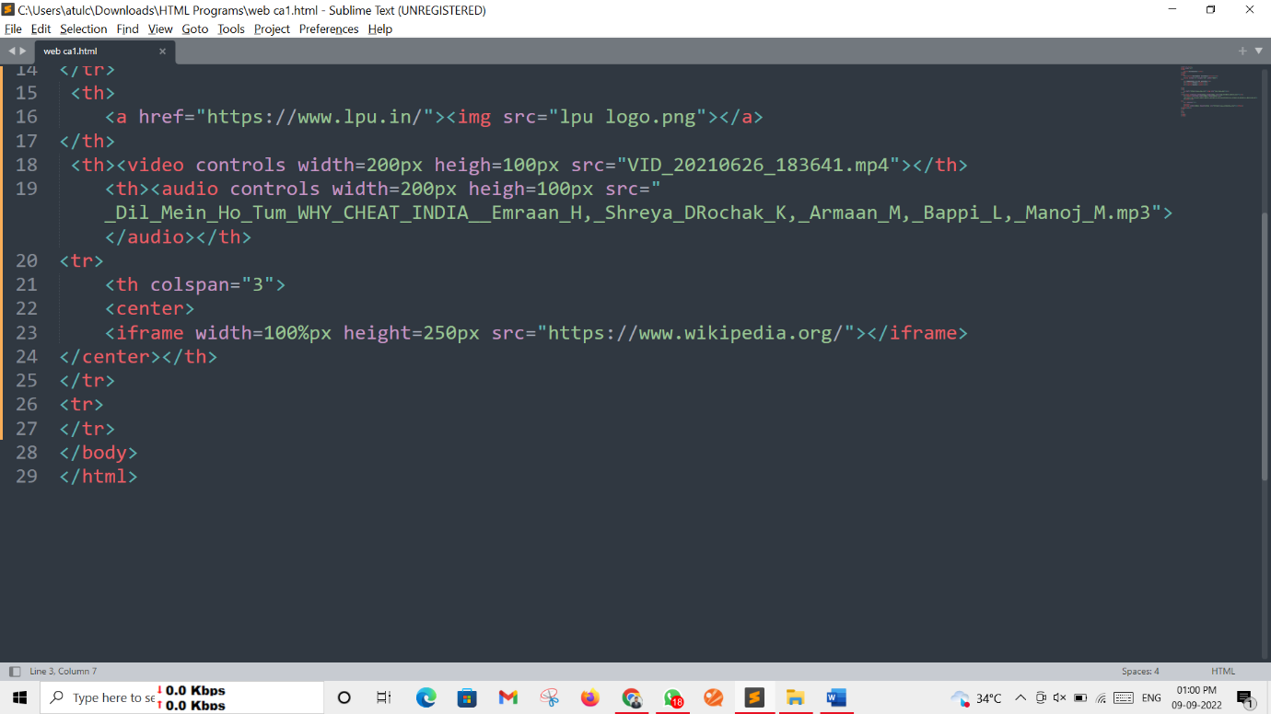
Output Screen: -
